**Windows 10 UWP – Hands on Lab**

**Lab 1:**

**Note**: This demo app created for this lab uses the Visual Studio 2015 RTM and Windows Tools SDK ver 10240.

1. Open VS2015 and create a new project. Once the “New Project” windows appears select “Blank App (Universal Windows)”. Name the project “HowToBBQ.Win10”. This will create a Windows 10 UWP.

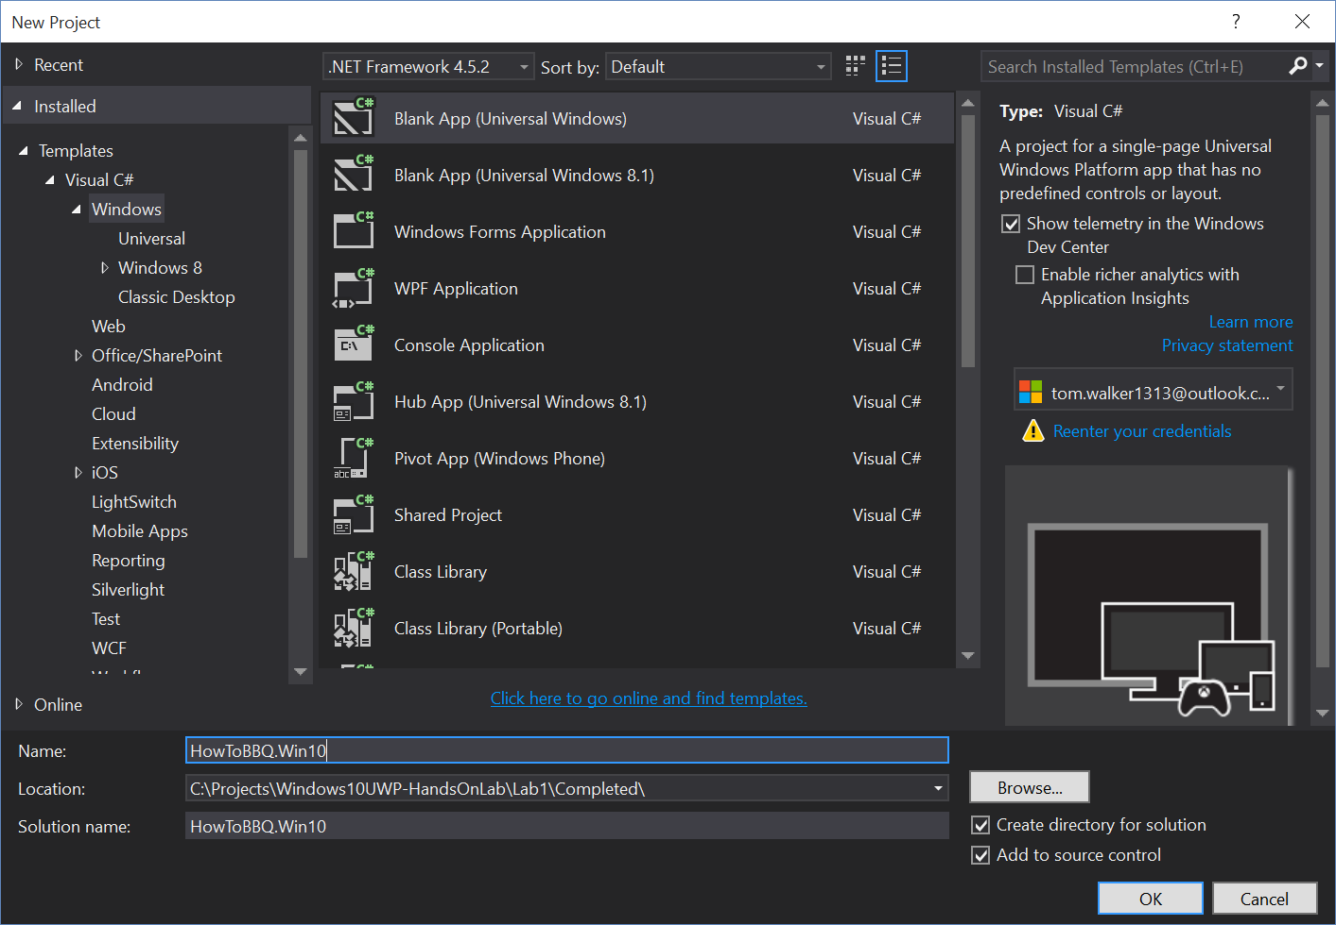

1. Hit F5 to run the app. This will test that your setup works.
2. Next create the following project folders “Views”, “Models”,”Mvvm”, and “ViewModels”.

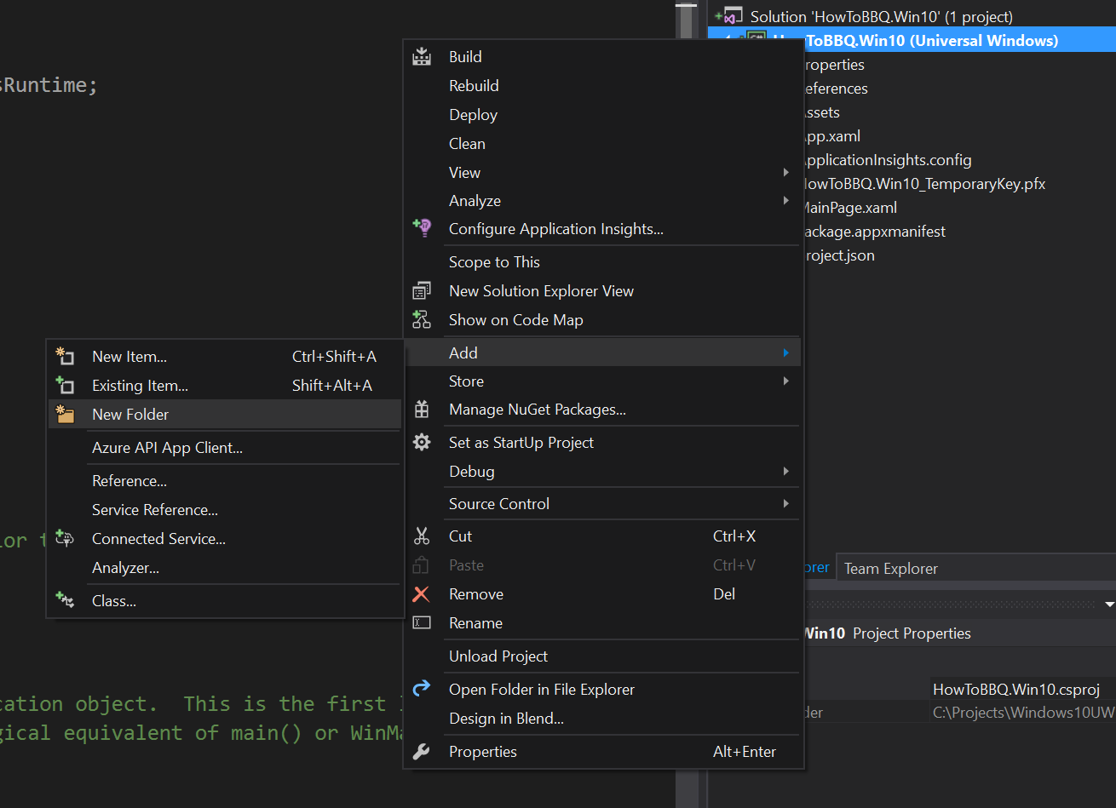

1. Now select the “Mvvm” folder and bring up the popup menu and select “Add->Existing Item”. This will bring up Windows Explorer. Navigate to the folder (ie. C:\Projects\Windows10UWP-HandsOnLab\Lab1\Start) where the lab files have been downloaded. Add all the files located in the “Mvvm” folder.

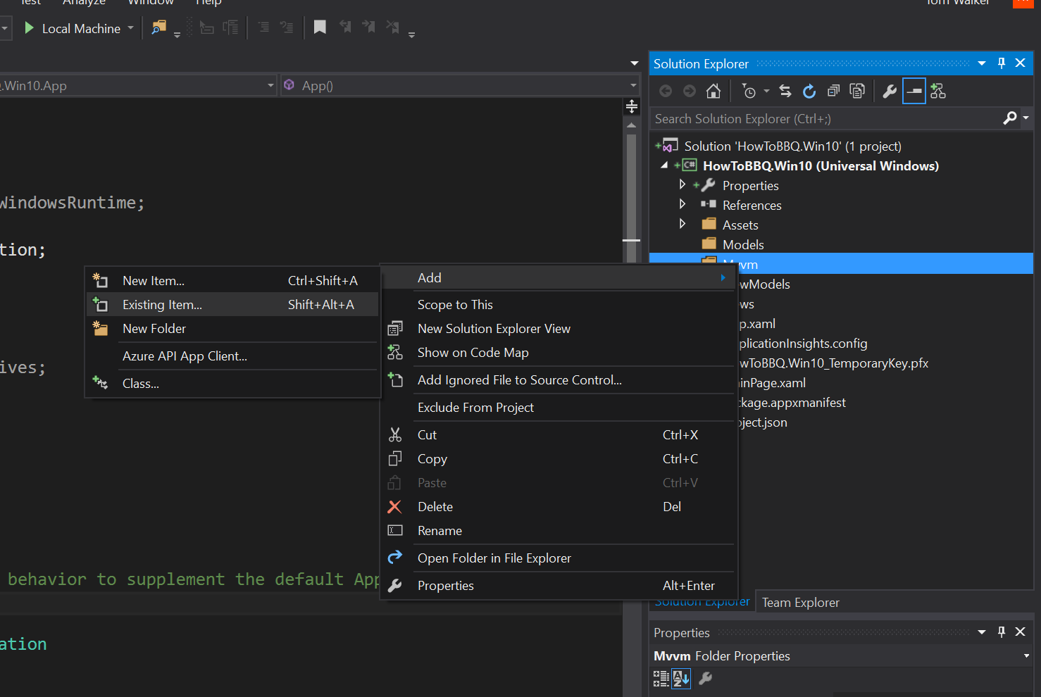

1. Now select the “ViewModels”folder and bring up the popup menu and select “Add->Existing Item”. This will bring up Windows Explorer. Navigate to the folder (ie. C:\Projects\Windows10UWP-HandsOnLab\Lab1\Start) where the lab files have been downloaded. Add all the files located in the “ViewModels” folder.
2. Now select the “Views”folder and bring up the popup menu and select “Add->Existing Item”. This will bring up Windows Explorer. Navigate to the folder (ie. C:\Projects\Windows10UWP-HandsOnLab\Lab1\Start) where the lab files have been downloaded. Add all the files located in the “Views” folder.
3. Next delete the MainPage.xaml file from the project.

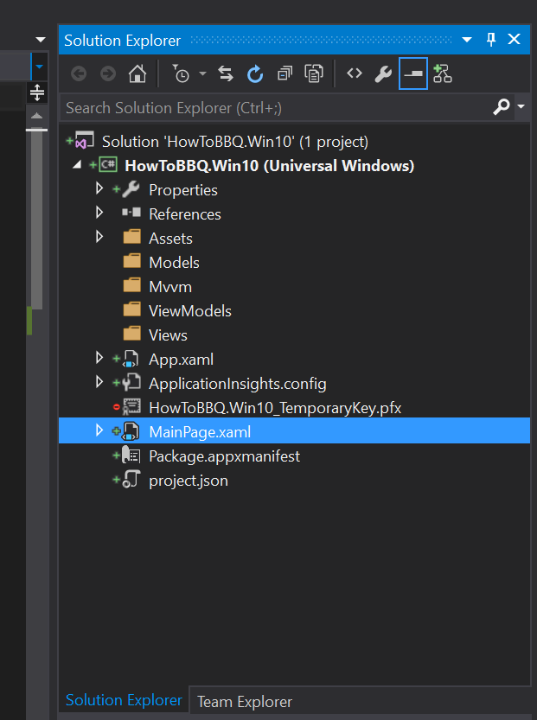

1. Now select the “Views” and add two new pages labelled “MainPage.xaml” and “BBQRecipePage.xaml”

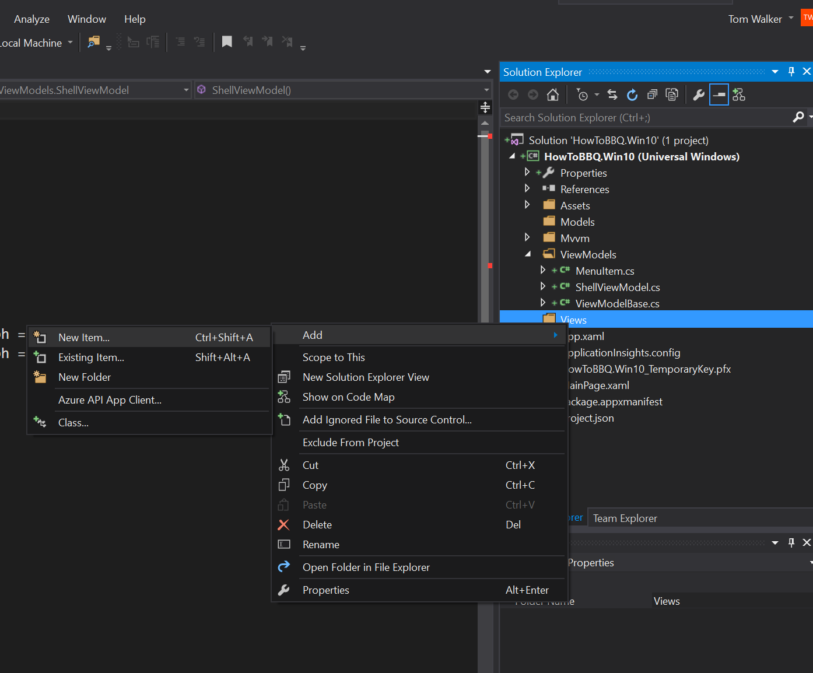

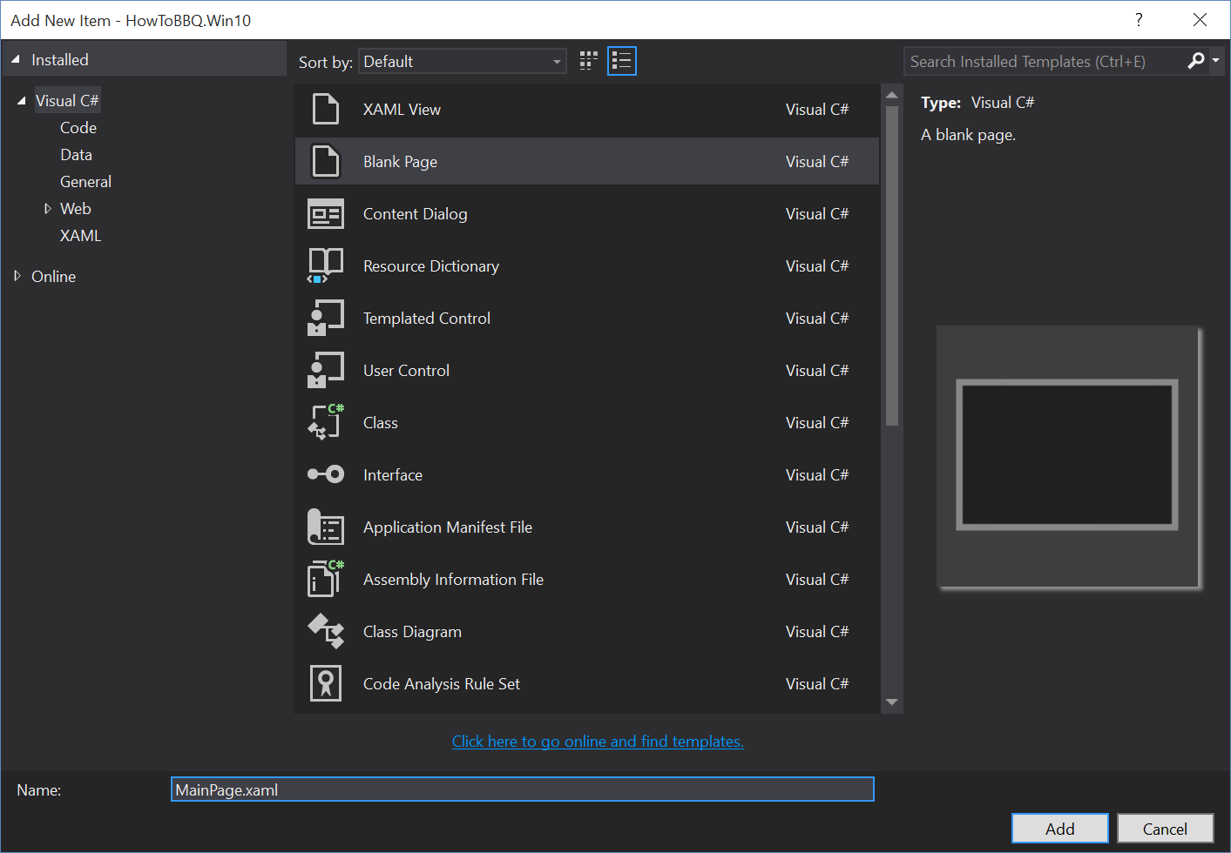

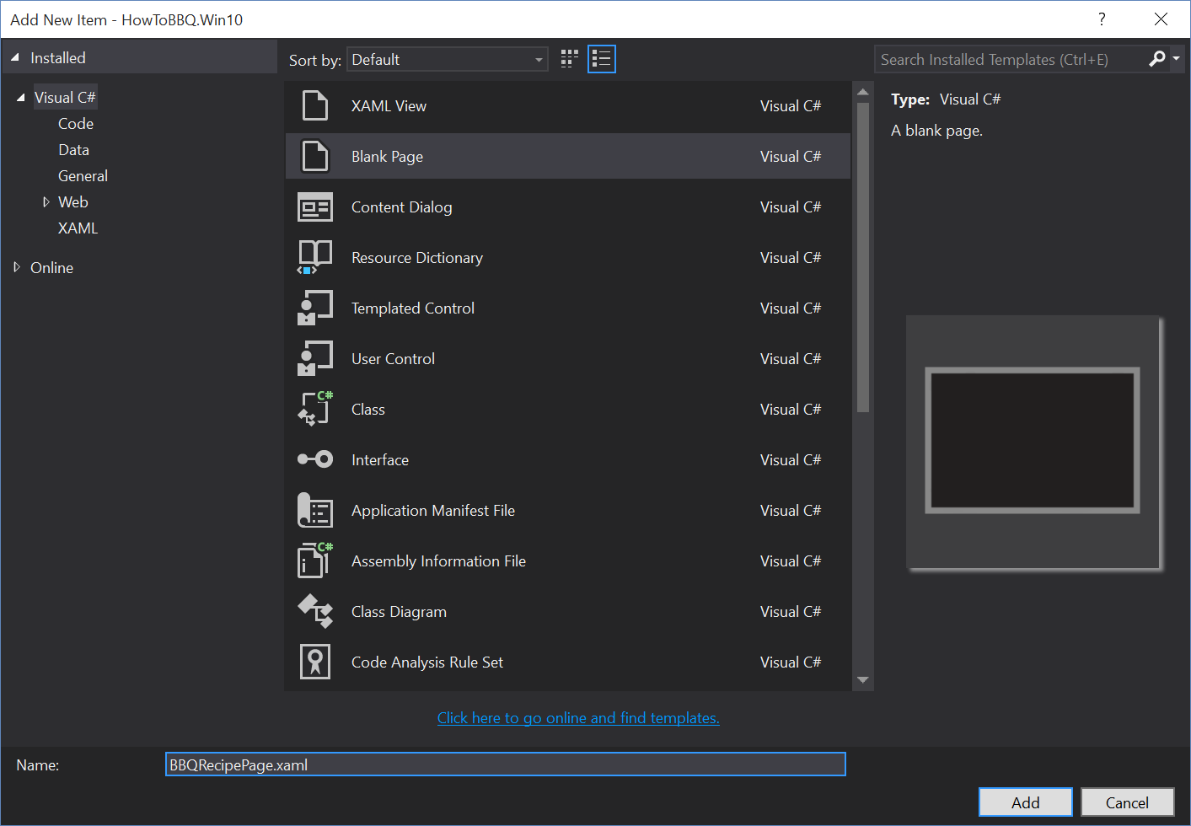

1. Open the “MainPage.xaml”. Make sure to select the “Xaml” view of the page to complete the next step. This option can be found on the bottom lower left of the code window.

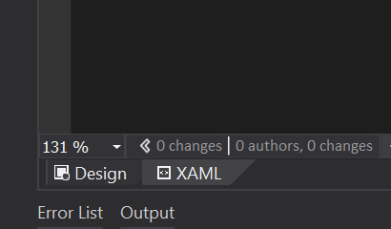

1. In the Xaml code panel of the page enter the following xaml code between the Grid tags.

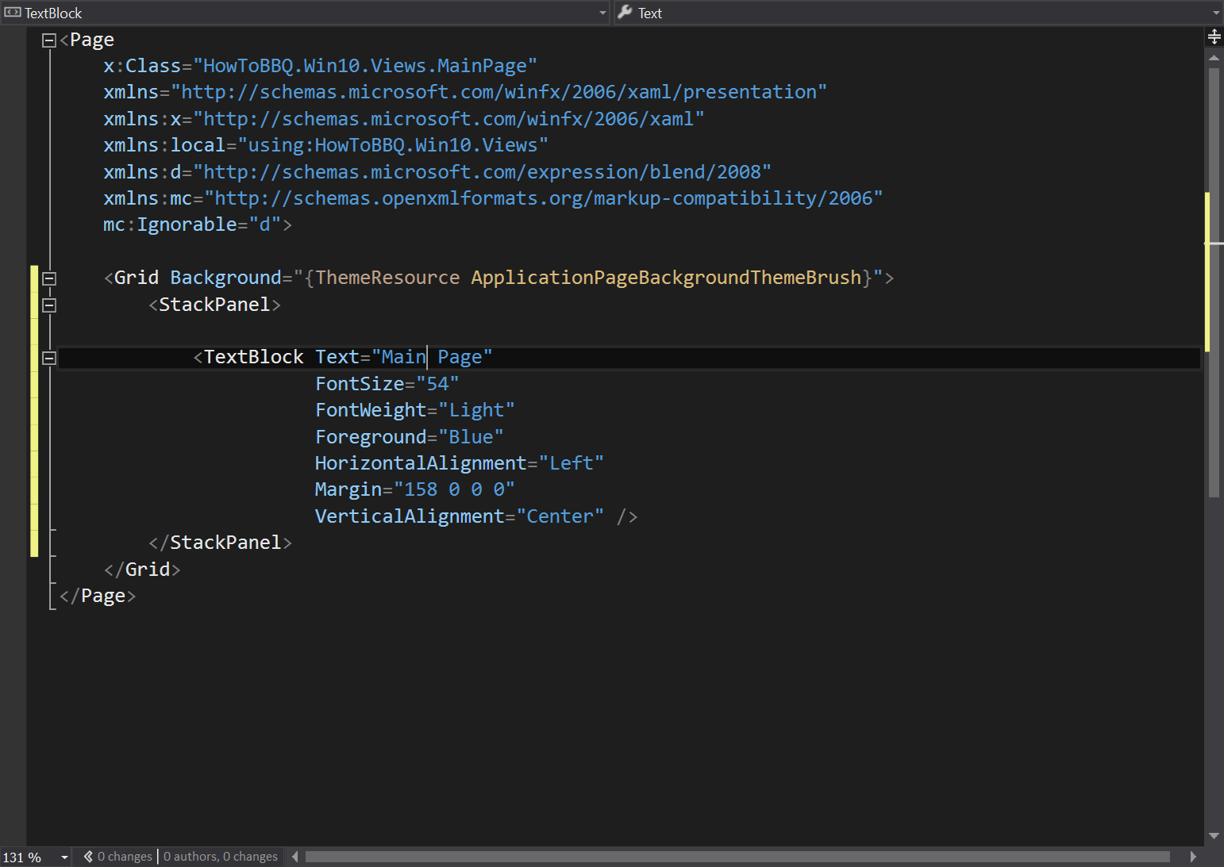

<StackPanel>

<TextBlock Text="Main Page"

FontSize="54"

FontWeight="Light"

Foreground="Blue"

HorizontalAlignment="Left"

Margin="158 0 0 0"

VerticalAlignment="Center" />

</StackPanel>

1. Open the “BBQRecipePage.xaml”. Make sure to select the “Xaml” view of the page to complete the next step. This option can be found on the bottom lower left of the code window.
2. In the Xaml code panel of the page enter the following xaml code between the Grid tags.

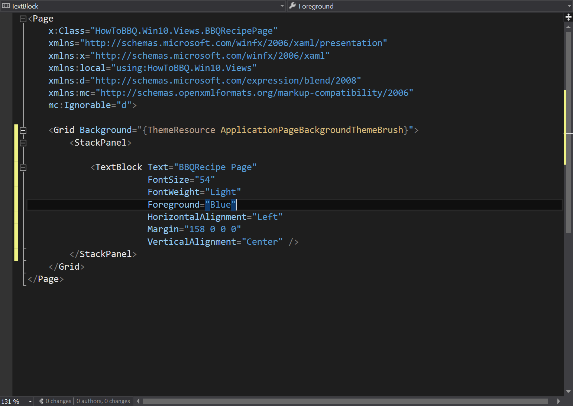

<StackPanel>

<TextBlock Text="BBQRecipe Page"

FontSize="54"

FontWeight="Light"

Foreground="Blue"

HorizontalAlignment="Left"

Margin="158 0 0 0"

VerticalAlignment="Center" />

</StackPanel>

1. Open the “App.xaml” within the file enter the following xaml code.

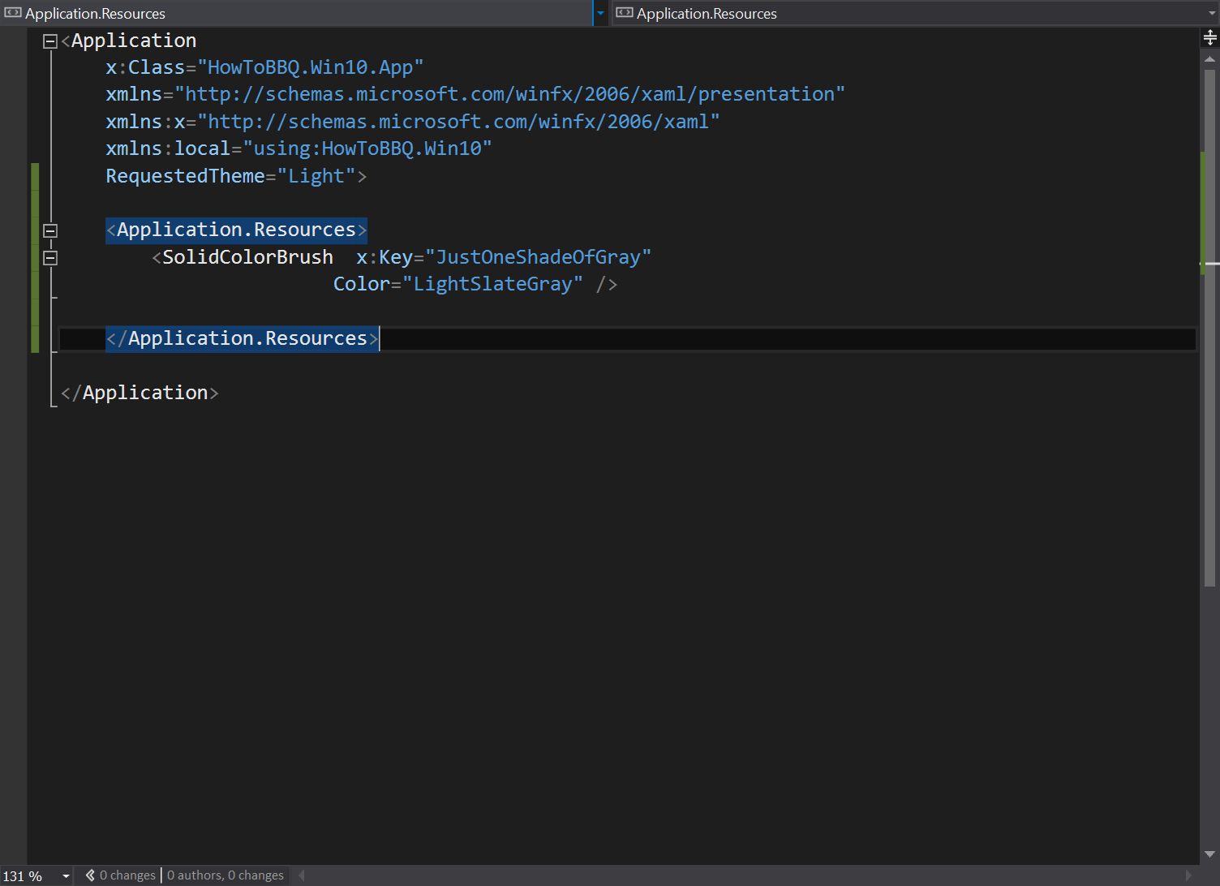

<Application.Resources>

<SolidColorBrush x:Key="JustOneShadeOfGray"

Color="LightSlateGray" />

</Application.Resources>

1. Now open the “App.xaml.cs”. The starting page for the application needs to change. Locate the following code line “rootFrame.Navigate(typeof(MainPage), e.Arguments);” The line is located on line 78. Replace the “MainPage” with “Shell”.

